IW-17
YEAR 10 SCIENCE
EARTH AND SPACE SCIENCE
ASSIGNMENT - ORIGIN OF THE UNIVERSE

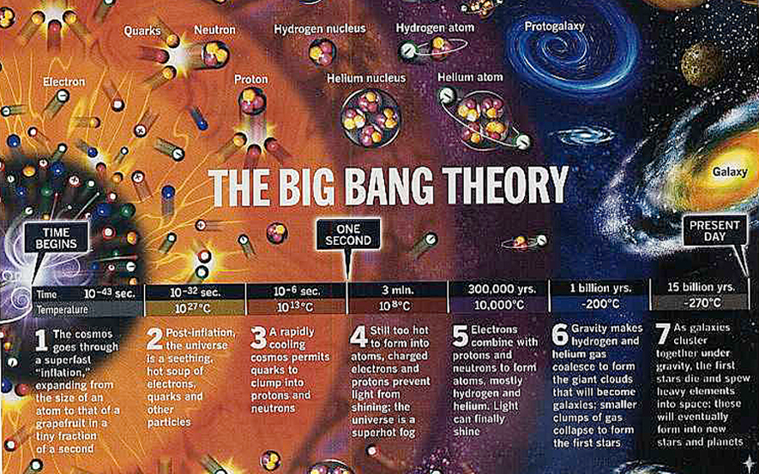

The research that you need to do for this assignment is divided into two main parts.

Either you can decide to deal with these as separate parts of your discussion or you can
mention both aspects throughout your discussion.

You MUST provide:

• Your written report.
• A reference list that is correctly formatted.

Task

Your research report shall:

1. give an explanation of the Big Bang Theory as it stands today and show how
the theory came about.
2. give the names and some history of the important people who helped to
develop the theory. Are there any Australians who have played a part?

CHECK THE RUBRIC TO MAKE SURE YOU HAVE HIT EACH OF THE CRITERIA
INCLUDED FOR MARKING.

(Hint: Einstein, Lemaitre and Hoyle are three scientists expected to be mentioned in
your research - they are NOT Australian, nor the only scientists involved. You will find more if you look!)

TIMELINE OF THE DEVELOPMENT OF THE BIG BANG THEORY

This timeline gives some of the major scientists and activities in the development of the Big Bang Theory, but it is not exhaustive. There are others who have contributed.

Use this as the basis for your research.

YEAR 10 SCIENCE
EARTH AND SPACE SCIENCE
ASSIGNMENT - ORIGIN OF THE UNIVERSE
MARKING RUBRIC

Name:

Marking Criteria | Marks
 | 0 | 1 | 2 | 3
Big Bang Theory
Description of a singularity given.
Explanation of how the expansion occurs and what takes place after it begins.
Contributing Scientists
Einstein - his contribution to the theory.
Lemaitre - how did he formulate his theory.
Hubble - what evidence did he present? Explain red-shift and how that applies to the theory.
Hoyle - explanation of the Steady State Theory.
Other scientists involved in developing the theory.
Describes the evidence that supports the theory.
Schmidt - what theory has evolved from his work?
Literacy
Used words appropriate to a general audience.
Grammar and spelling.
Correctly referenced sources of information.
TOTAL

Comment

